**Bug report 1**

calculator-app.exe

**Bug 1: Calculator-app closes after press in buttons / , * , + , - , =**

**Environment/URL:** calculator-app.exe

**Operation system:** Windows 64

**Version:** 1

**Browser:** —

**Submit date :** 29.04.2021

**Reporter:** Hayk Poghosyan

**Steps to reproducer:**

1. Open application
2. Press in buttons / , * , + , - , = when field is empty

**Expected result:** The application should not be closed

**Actual result:** Press in buttons /, * , + , - , = when number field is empty, app .closes

**Screenshot/video:** Screenshot is attached

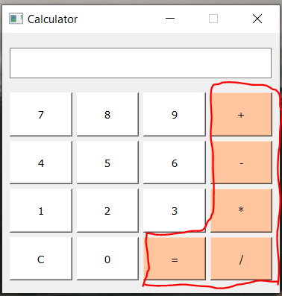

**Note:** The application should not be close after pressing another button

**References:**

**Severity:** Critical

Bug report 2

Beta testing <https://boardlyapp.com/> web application

**Bug 2:** Creat new board with a non- existent email

**Environment/URL:** <https://boardlyapp.com/>

**Operation system:** Windows 64

**Version:** -

**Browser:** Google Chrome version 90.0.4430.93

**Submit date :** 01.05.2021

**Reporter:** Hayk Poghosyan

**Steps to reproducer:**

1. Open URL
2. Write board name and email

**Expected result:** You must login with really email with reali domain

**Actual result:** You can login with a non- existent email, [kjhjhhgjgj@gmail.ru](mailto:kjhjhhgjgj@gmail.ru)

**Screenshot/video:** Screenshot is attached

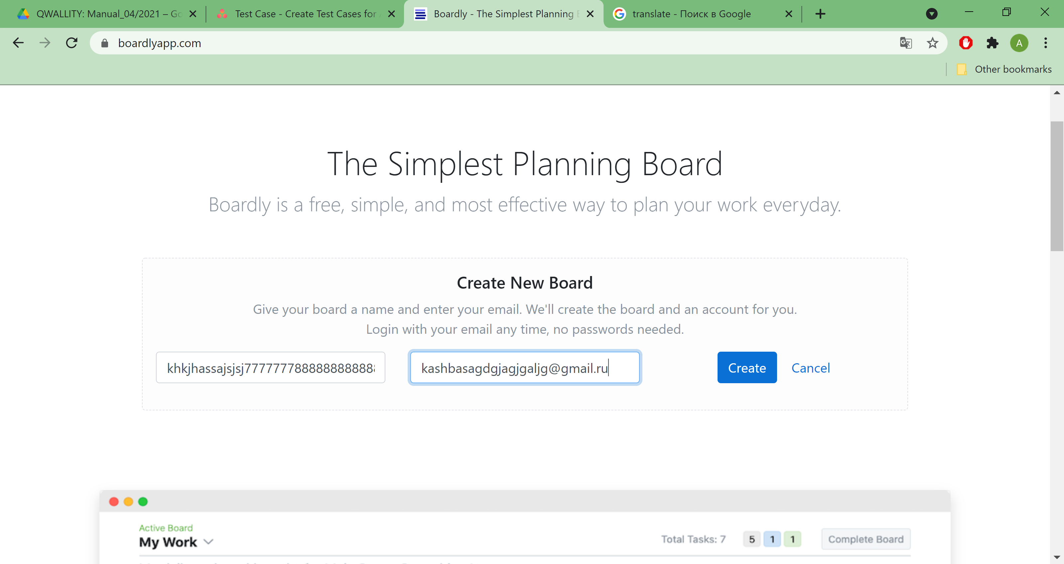

**Note:** You can’t login with a non- existent email

**References:-**

**Severity:** Critical